http://www.british-forces.com/cig/aircraft/avroyork.html


685 York
Role
Fighter
Close-Support
Counter-Insurgency
Tactical-Strike
Strategic-Bomber
Tactical-Reconnaissance
Strategic Reconnaissance
Maritime Patrol
Anti-Ship Strike
Anti-Submarine Warfare
Search and Rescue
Assault Transport
Transport
Liaison
Trainer
Inflight Refuelling Tanker
Specialized
Glider
Capability
All-Weather
STOL
VTOL
Rough-Field
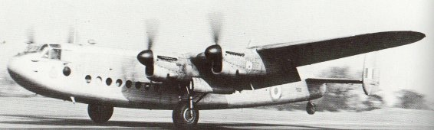
Avro 685 York
Aircraft Type: | Long-range passenger and cargo transport
First Flight: | 5/7/42
Entered Service: | 3/1943
Specification
Powerplant: | 4 1280hp Rolls-Royce Merlin XX inline piston engines
Performance
Speed (Kmph): | 480 at 6400m; cruise 338kmh
Range (Km): | 4345
Service Ceiling (m): | 7010
Dimensions
Wingspan (m): | 31.09
Wing Area (m2): | 120.49
Length (m): | 23.93
Height (m): | 5.44
Weights
Empty Weight (Kg): | 19069
Maximum Take Off Weight (Kg): | 31115
Weaponry
Guns: | None
Bombs etc: | None. Large passenger lift capacity
Crew: | ?
Notes: | Small wartime usage (4) but picked up considerably after the war. One of these aircraft was used by Churchill as a flying conference room.
Versions
C.Mk 1 | Production model
C.Mk 2 | 1 converted prototype fitted with four 1650hp Bristol Hercules Vi engines
Aircraft of the RAF

 | Sign My Guestbook  View My Guestbook | These pages are part of  british-forces.com.  © 2000 british-forces.com.  All rights reserved.  Copyright Disclaimer | Can't find what  you're looking for?  Make a Suggestion

Avro York MW 169 was originally built for the Royal Air Force just before the end of the war. However it was diverted to the French Armee de l'air for use by General Charles De Gaulle in June 1945.

Also in 1955 Avro 685 York 1 aircraft were acquired and converted to freight operation in advance of a new proposed Europe-West Africa cargo service. For this operation a new airline, Hunting-Clan African Airways Ltd, was set up in Salisbury (Rhodesia) with a view to handling European cargo and also regional cargo flights. The 'Africargo' service began in July using an Avro York with a weekly freight flight from Heathrow to Salisbury. Cooperation with BOAC and Airwork in African air-freight developments were agreed and flights were arranged to link with Airwork's own cargo flights to the USA.
The London-Paris fare was cheaper than BEA's (Skyways was seven pounds and five shillings against BEA's fare of nine pounds seventeen shillings). But BEA flew from Northolt west of London to Paris whereas Skyways used a coach to drive to Lympne near Dover and the flight was to Beauvais on the French coast where a train took the Skyways passengers into Paris itself - a six hour trip compared to the BEA flight of only 3 and a half hours

