http://www.british-forces.com/cig/aircraft/prentice.html

Prentice T.1
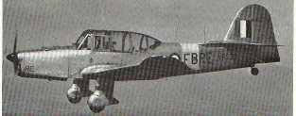
Percival Prentice T.1
Aircraft Type: | Trainer
First Flight: | 31/3/46
Entered Service: | 1947-1953
Specification
Powerplant: | 1 de Havilland Gipsy Queen 32, inline 6-cylinder air-cooled 251hp
Performance
Speed (Kmph): | 230 at 1525m
Range (Km): | 637
Service Ceiling (m): | 5490
Dimensions
Wingspan (m): | 14.02
Wing Area (m2):
Length (m): | 9.52
Height (m): | 3.91
Weights
Empty Weight (Kg): | 1469
Maximum Take Off Weight (Kg): | 1905
Weaponry
Guns:
Bombs etc:
Crew: | 2
Notes:
Versions
T.1 | Main production version

