http://www.oldprops.f9.co.uk/Britannia.htm

Bristol Britannia

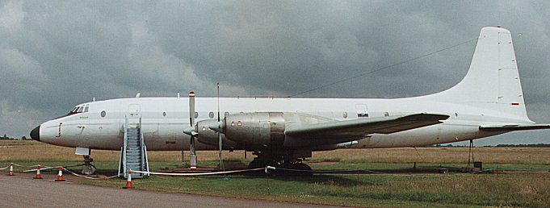
Britannia C1 XM496 was delivered new to the Royal Air Force in 1960 and named Regulus. After being withdrawn from use at Kemble in 1975 it donned the civil identity G-BDUP with Afrek and later served with Aerocaribbean in Cuba as CU-T120 and Trans Air Cargo in Zaire as 9Q-CJH and EL-WXA. It made the last Brit flight in 1997 when it returned to Kemble for preservation with the Britannia Aircraft Preservation Trust. Its ultimate home may well be Filton.

The Bristol Britannia is considered by many as the ultimate turboprop engined airliner - certainly anyone who saw one fly could not have failed to have been impressed by its sheer majesty.
But as a commercial project it must rank as an abject failure - just 85 were built and the type's prolonged development saw it overhauled by jets just when the project was finally getting off the ground.
While a key factor in its delayed entry into service was the inevitable problems experienced with a new technology - in this case turboprop engines - a major factor was the rather arcane British system of ordering aircraft which existed at the timeand which was to lead to numerous redesigns.
So closely was the type tailored to BOAC's needs that the result was to be an aircraft which had limited appeal to other airlines and , in a situation that was to blight other types such as the Comet, VC10 and Trident, was to hand the lion's share of the world airliner market to the far more commercially aware giants of Boeing and Douglas.
The initial requirement C2/47 was issued by the Ministry of Supply on behalf of BOAC for a medium range Empire airliner. BOAC initially ordered an aircraft capable of carrying just 48 passengers and powered with Centaurus radial engines.
Turboprop and compound engines were also considered but Bristol would not guarantee the aircraft's ability to fulfill the specification with these engine types.
After wrangling between the MoS and BOAC over costs the go-ahead was given in July 1948 for three radial-engined prototypes, although the second and third were to be convertible to Proteus turboprops.
But in October BOAC threw the project into confusion by deciding a Proteus-engined aircraft deserved a start and the project was now redrawn to allow for both turboprop and piston aircraft.
BOAC finally signed up for 25 aircraft in July 1949, the first six with the Centaurus engine and the rest with the Proteus, and now enlarged for 74 passengers.
By the time the first prototype took to the air on August 16, 1952 BOAC and Bristol had dropped the Centaurus plan as the turboprop Proteus had shown such promise. The Britannia was now a 90-seater and BOAC ordered 15 series 100s.
Sadly a series of engine problems - mostly centred on icing - was to delay the in-service date until February 1957, when BOAC put their first Britannia 102s into service on the London to South Africa route, with Australia following a month later.
The ultimate model was the 300 series ordered by BOAC for its Trans-Atlantic services. This had a fuselage stretched by 10ft 3 in (3.12m) and 45 were built. But by the time it flew in the shape of 301 G-ANCA, on July 31, 1956 the jet age was just around the corner.
BOAC ordered seven 302s but never took delivery of them - instead they were taken on by several other airlines including Aeronaves de Mexico and Ghana Airways.
The main long range version was the 312, of which BOAC took 18 and, after deliveries began in September 1957, put them into service between London and New York.
The Royal Air Force took delivery of 25 series 252 and 253 long fuselage versions with a forward freight door and a specification basically similar to the 310.
The final version was the 320 with uprated Proteus 765s although just two - for Canadian Pacific- were built in this series as 324s. Several in the 310 series were also completed to this standard.
BOAC retired its Brits from 1965, many passing to British Eagle, and these gave sturdy service along with those of Britannia Airways and Monarch in the British charter market until the early 1970s.
A new lease of life came in the mid 1970s when several RAF freighters came on to the market and were snapped up by British, European and African carriers.
The type slowly dwindled in number until the end came with the final flight of EL-WXA to preservation at Kemble in England in 1997.

Contents | Photos and Census | News
To comment on this site or send additional information e-mail oldprops@hotmail.com
All photographs and material Copyright Paul Middleton © 1999-2000

http://views.vcu.edu/~tcrabb/brit.html

The Bristol Britannia


in the Royal Air Force
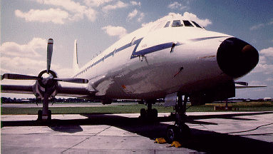  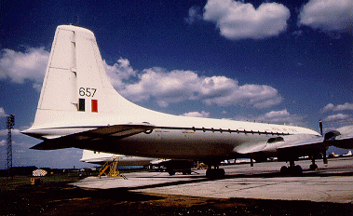 | The Britannia Fleet  XL635 Bellatrix  XL636 Argo  XL637 Vega  XL638 Sirius (Sole casualty - Destroyed in Aden 1967)  XL639 Atria  XL640 Altares  XL657 Rigel  XL658 Adhara  XL659 Polaris  XL660 Alphard  XM489 Denebola  XM490 Aldebaran  XM491 Procyon  XM496 Regulus  XM497 Schedar  XM498 Hadar  XM517 Avior  XM518 Spica  XM519 Capella  XM520 Arcturus  XN392 Acrux (Mk2)  XN398 Altair (Mk2)  XN404 Canopus (Mk2)

Brit Det: The Britannia in the Far East
More Photos
Fly the RAF Britannia!
Keyham Books - publisher of "The Whispering Giant in Uniform"
The Britannia Aircraft Preservation Trust

http://aviation-safety.net/database/type/111.shtml

Bristol 175 Britannia
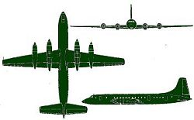 | Bristol 175 Britannia  1st flight: 1952  Series:  4 prop engines  max. 139 passengers  85 built  prod. ended: 1960
Relevant Bristol 175 Britannia safety related information on the internet:
-
Listing of all accidents in which the aircraft involved was damaged beyond repair:
04 FEB 1954 | Bristol 175 | G-ALRX | 0(13)
 | Ministry of Supply | Severn Estuary
06 NOV 1957 | Bristol 175 | G-ANCA | 15(15)
 | Ministry of Supply | Downend
24 DEC 1958 | Bristol 175 | G-AOVD | 9(12)
 | BOAC | Winkton
11 NOV 1960 | Bristol 175 | G-ANBC | 0(27)
 | BOAC | Khartoum
22 JUL 1962 | Bristol 175 | CF-CZB | 27(40)
 | Canadian Pacific Air Lines - CPAL | Honolulu IAP, HI
29 FEB 1964 | Bristol 175 | G-AOVO | 83(83)
 | British Eagle International Airlines | Mt. Glungetzer
09 JUL 1965 | Bristol 175 | XA-MEC | 0(82)
 | Aeronaves de Mexico | Tijuana
01 SEP 1966 | Bristol 175 | G-ANBB | 98(117)
 | Britannia Airways | Ljubljana
20 APR 1967 | Bristol 175 | HB-ITB | 126(130)
 | Globe Air | Nicosia
20 APR 1967 | Bristol 175 | G-ANCG | 0(65)
 | British Eagle International Airlines | Manston
12 OCT 1967 | Bristol 175 | XL638 | 0()
 | Royal Air Force - RAF 99/511 sqn | RAF Khormaksar
12 JUL 1970 | Bristol 175 | LV-JNL | 0(12)
 | Aerotransportes Entre Rios - AER | Buenos Aires-Ezeiza APT
30 SEP 1977 | Bristol 175 | EI-BBY | 0(6)
 | Interconair | Shannon
16 FEB 1980 | Bristol 175 | G-BRAC | 7(8)
 | Redcoat Air Cargo | Billerica, MA
[disclaimer]

Copyright © 1996-2001 Harro Ranter / Fabian Lujan
Aviation Safety Network; updated 24 May 2001

http://www.1st-take.com/bristol_britannia_story_frame.htm

 | THE BRISTOL BRITANNIA STORY  The full story of arguably the most successful aeroplane ever to be produced in Bristol is now available on video.  In July 1948 the Ministry Of Supply submitted an order for three Bristol 175 type aircraft, following ideas developed by the Brabazon committee. ‘Brabazon III’ ran in parallel with the ill-fated Brabazon project and eventually became known as Britannia. Its development was riddled with setbacks, as two aircraft were lost in test flights, and there were technical problems with the Bristol Proteus engines.  The Filton workforce overcame these hurdles and the Britannia became the first aircraft to carry 100 passengers non-stop both ways across the Atlantic.  The video is enhanced by the memories of test pilots Walter Gibb and Godfrey Auty, together with recollections of key personnel who helped to design and build the Britannia. Extensive archive film, illustrating Britannia’s promotional tours of the 1950s, and remarkable photographs provide a stunning visual backdrop to this fascinating story.  Click here to contact us and order
  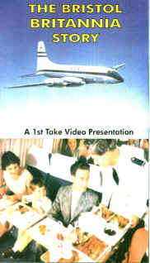
  Code: 00205
  Duration: 90 mins
  Price: £14.95

