http://www.british-forces.com/cig/aircraft/avroanson.html

652A Anson
Role
Fighter
Close-Support
Counter-Insurgency
Tactical-Strike
Strategic-Bomber
Tactical-Reconnaissance
Strategic Reconnaissance
Maritime Patrol
Anti-Ship Strike
Anti-Submarine Warfare
Search and Rescue
Assault Transport
Transport
Liaison
Trainer
Inflight Refuelling Tanker
Specialized
Glider
Capability
All-Weather
STOL
VTOL
Rough-Field
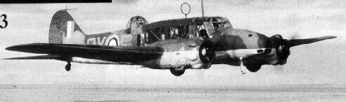
Avro 652A Anson
Aircraft Type: | Trainer or Communications aircraft
First Flight: | 24/3/35
Entered Service: | 6/3/36
Specification
Powerplant: | 2 350hp Armstrong Siddeley Cheetah IX radial piston engine
Performance
Speed (Kmph): | 303 at 2135m; Cruise at 254 kmh
Range (Km): | 1271
Service Ceiling (m): | 5790
Dimensions
Wingspan (m): | 17.2
Wing Area (m2): | 38.09
Length (m): | 12.88
Height (m): | 3.99
Weights
Empty Weight (Kg): | 2438
Maximum Take Off Weight (Kg): | 3629
Weaponry
Guns: | One .303in fixed forward firing machine gun and one .303in gun in dorsal turret
Bombs etc: | 360lb of bombs
Crew: | 3/5 (8-11 for Communications role)
Notes: | Various Marks upto Anson 19 Series 2. Service career spanned 22 years.
Versions
Mk I and Gr Mk I | Initial production version
Mk II | Re-designed nose section
Mk III | Trainer; Two 330hp Jacobs 1.6MB
Mk IV | British airframes; Two 300hp Wright Whirlwinds fitted in Canada
Mk V prototype | Conversion of Mk I and Mk IV
Mk V | American-built trainer; Two Pratt & Whitney Wasp Juniors
Mk VI | Gunnery trainer; as Mk V but with Bristol Turret
Mk X | Transport; Strengthened cabin floor
Mk XI | Transport; Two 395hp Armstrong Siddeley Cheetah 19s
Mk XII | Transport; Two 420hp Cheetah Is; Fitted with spinners
Mk 18-22 | Post-War developments
Aircraft of the RAF

 | Sign My Guestbook  View My Guestbook | These pages are part of  british-forces.com.  © 2000 british-forces.com.  All rights reserved.  Copyright Disclaimer | Can't find what  you're looking for?  Make a Suggestion

The Avro Anson earned its nickname of "Faithful Annie" by serving the RAF from 1934 to 1968. To meet the G.18/35 requirement for Coastal Command, a design team lead by Roy Chadwick adapted the Avro 652. This had been designed for Imperial Airways, as a small four-seat transport and mail aircraft. The modified aircraft was the 652A, easily recognizable because it had large square windows instead of smaller oval ones, and was fitted with a dorsal gun turret. In 1936 the type entered service with No.48 Squadron, Coastal Command, as the Anson Mk.I. Until the Hudson replaced it, Coastal Command used the Anson for maritime reconnaissance and search & rescue. However, many of the 6742 Anson Mk.Is built were used as trainers. The Anson became the standard twin-engined trainer, and its original role was forgotten. 11020 were built, in a large number of versions, but only the Mk.I was used for maritime patrol.
The Anson Mk.I was a low-wing monoplane with retractable landing gear, a first for the RAF --- in fact so new that crews all too often forgot to perform the necessary task of turning a crank 160 times to wind down the landing gear. Of course there was a warning horn, but this was so irritating that many pilots disconnected it! Another concession to modern times was a blind flying panel. The construction, on the other hand, was thoroughly conventional: the wing was made of spruce and bakelite-bonded plywood, and its fuselage of steel tube with fabric and plywood covering. Originally the Ansons were painted with a shiny aluminium dope, but after the outbreak of war camouflage paint was applied. The cockpit with its large windows gave a good view all around. The engines were Armstrong Siddeley Cheetah IX radials, with two-bladed metal propellers. They were sufficient, but only just: If one engine failed the chances of staying in the air on the other one were slim.
The Anson had a crew of four: pilot, bomb aimer, gunner, wireless operator. The General Reconnaissance version had a manually-operated gun turret with a single .303 gun, and a fixed gun in the nose. The air gunners were volunteers drawn from the groundcrew, who received an additional shilling a day to their pay. Two 100lb bombs could be stowed internally, and external racks could carry eight 20lb bombs, flares or smoke generators.
The Anson was sturdy, reliable and pleasant to fly, and it was well-liked by its crews. It was a great success as a trainer. But as maritime reconnaissance aircraft it was a failure: Slow, vulnerable, short-ranged, with pitifully weak armament. The ineffectiveness of the 100lb bomb was illustrated in December 1939, when the British submarine HMS Snapper was attacked in error, hit directly, and suffered four broken lightbulbs. That Ansons were the mainstay of Coastal Command in 1939 illustrates the weakness of this service. Their replacement by Hudsons was a major step forward.
In 1939 RAF Coastal Command's standard reconnaissance aircraft was the Avro Anson. The Avro 652 monoplane airliner entered Imperial Airways service in 1934 and it was from this design that the long-serving Anson was derived.  The Anson entered RAF Coastal Command service in February 1936 on general reconnaissance duties and was the RAF's first monoplane and its first aircraft with a retractable undercarriage. | 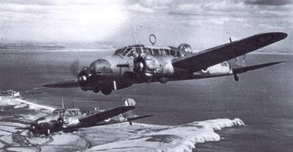  Ansons of N0.217 Squadron on coastal reconnaissance, France 1940 (IWM neg C2118)
On 5 September 1939 an Anson of No. 500 Squadron made the first RAF attack of the war on a German submarine. In June 1940, three Ansons attacked over the English Channel by nine Messerschmitt 109s succeeded in shooting down two and damaging another of the fighters. For most of its long service, however, the Anson was used in light transport and training roles and most RAF and Commonwealth navigators, wireless operators and air gunners trained on 'Annies'. The Anson officially retired from RAF service in June 1968.

Avro Anson Mk.I
Two 320hp Armstrong Siddeley Cheetah IX engines
Wing span | 17.22m
Length | 12.8m
Normal loaded weight | 3476kg, max weight 3627kg
Max Speed | 272 km
Range | 1062 km
____________________

http://www.yeovilton.org.uk/avroanso.htm

Avro Anson
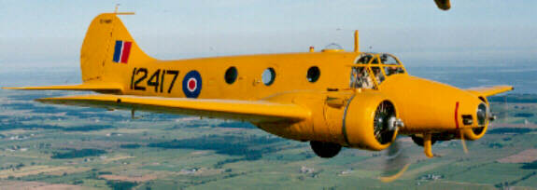

"used by all TAGs who trained in Yarmouth as we did not have enough Swordfish. I well remember trailing and winding back the very long anntena in the Anson and it was the TAGs job to pump the U/C up and down at the pilots request. In the air quite a few TAGs "flew" the craft for a short period: there was a second control and joystick where we sat up front next to the pilot" - Bill West Ex TAG (now residing in Australia)
The Avro Anson had the distinction of being the first monoplane in service with the RAF. Originally designed as a six passenger commercial aircraft in the early 1930's, its merit as a general reconnaissance aircraft for Coastal Command was quickly noted by the British Air Ministry.
The Anson entered service in 1936 and proved itself to be a reliable design. At the outbreak of hostilities, three years later, the Avro 652 Anson was found to be obsolete in its primary role (it was replaced by the Lockheed Hudson).
Retirement from combat meant employment as a trainer. The Avro Anson quickly became the backbone of the British Commonwealth Air Training Plan (BCATP), as a multi-engined trainer and light utility transport.
In total, over 11,000 Anson were built, and many postwar versions continued to be used until recently by both military and civilian companies around the world.
The CWH Anson MK V-P is a long range photographic version. It is an all wooden aircraft, built by MacDonald Bros., Winnipeg, in 1944. It was donated by INCO Ltd., who had used it in the post-war era for mineral surveying. CWH's C-FHOT, and C-FHQZ in Vancouver, are the only Mk V's flying in Canada and possibly the world.

